Center for Nursing Media Campaign RFP# 115517 O3

Attachment 1: Excepts from the 2022 Biennial Report

Table 8 illustrates the expected growth and nursing workforce gap for each type of nurse in the State of Nebraska through the year 2025.

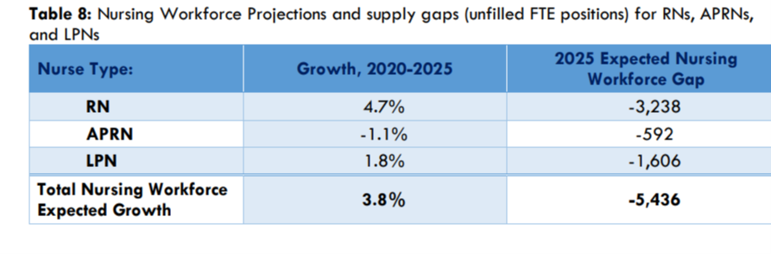

The Center for Nursing has a current website https://center4nursing.nebraska.gov.

Strategic Goals and a link to the defining statute can be found at:
https://center4nursing.nebraska.gov/about.

Current Shortage Data (2022 biennial report) and Workforce Supply and Demand information can be found at https://center4nursing.nebraska.gov/data

The 2022 biennial report illustrates nearly 2,600 fewer nurses (RNs, APRNs, and LPNs) working in Nebraska when compared to 2018/19 (24,531 vs. 27,106, respectively), which represents a decrease of 9.5% in the nursing workforce.

6.9% of nurses (RNs and APRNs) are very likely to leave their primary employment over the next 12 months compared to 5.9% in 2018. The largest generation group of nurses who are planning to leave their employment are Generation Y/Millennials (43%), followed by Baby Boomers (25%), and then by Generation X (24%).

Nearly 1,000 nurses between the ages of 24 and 55 are “very likely” to leave their employment over the next 12 months. They represent two-thirds of all nurses who are planning to leave their employment over the next 12 months.

This graph provides a snapshot of RNs per generational group.
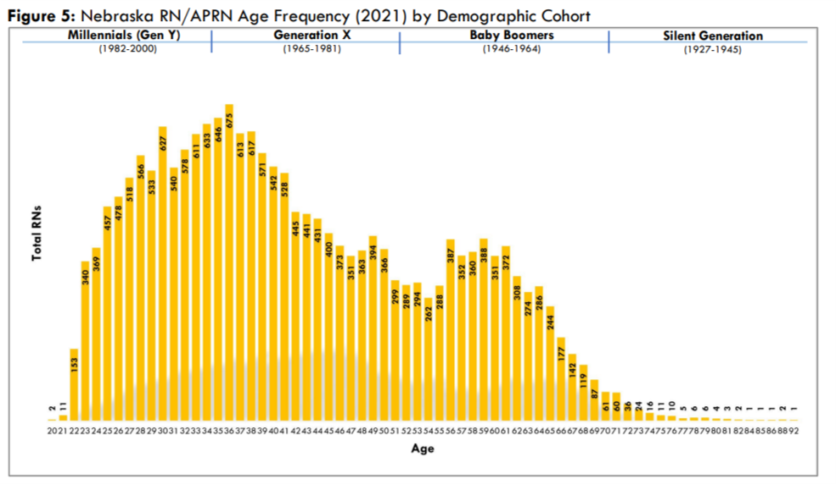
What is interesting, yet concerning about this snapshot is that the NE Baby Boomer’s are just now in 2022-23 beginning to retire in droves. That means we must retain the Gen X and Millennials (Gen Y) to uphold the existing workforce in NE. This is bound to change the way students are recruited into nursing, as well as ongoing models of care delivery and work environments. Millennial workers are not the same as Baby Boomers and have very different work life balance expectations.

Couple the generational issues with the demand and the numbers are staggering. The following graph shows the scene in another way, complicated by the increased need for nursing care based on the future health needs of Nebraskans.

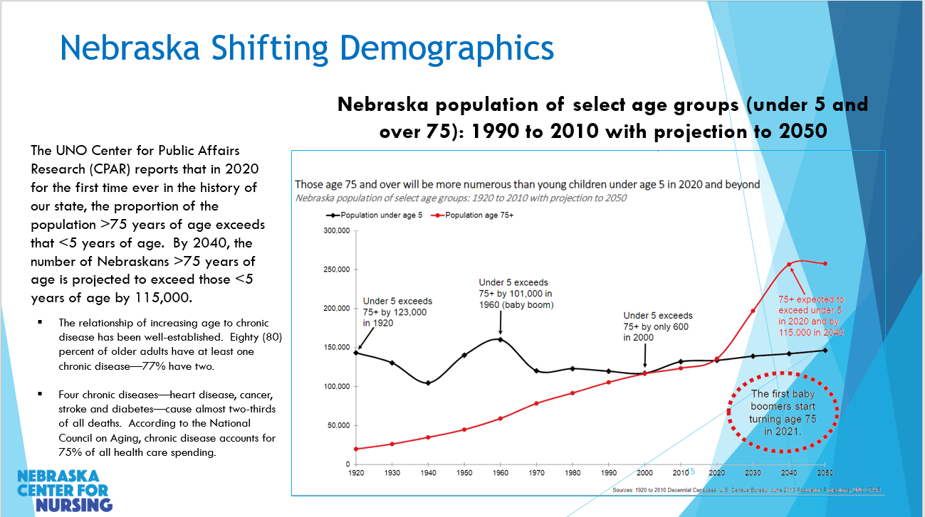

One must also examine the supply side of the supply vs demand model for nurses in NE.

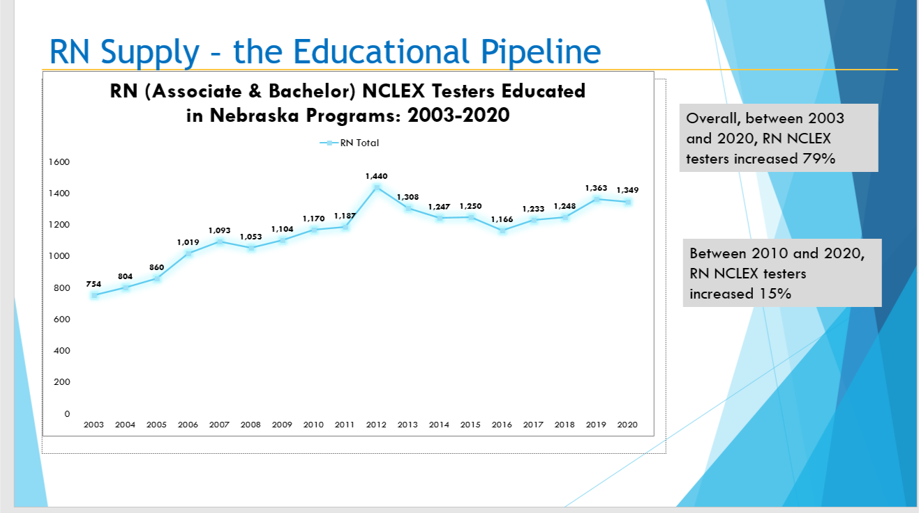

Nurses primarily increase through production (or education). The above snapshot substantiates that Nebraska schools rose to the challenge from the last shortage in 2000 and have increased graduates who have licensed in the state of NE by nearly 80%.

